Girls MUST complete this form for solicitation letters to businesses. Follow the guidelines listed below.

- Fill in all of the blanks and remove all extra lines and underlining from your letter.
- DO NOT REVISE ANY OTHER SECTION OF THE LETTER.

- Be sure to list the quantity and size, if applicable, of the supplies you are requesting.
- A gift card cannot be requested, however, the business may decide to donate a gift card in lieu of supplies.

- Create a new letter for each business.
- PROOF READ EACH LETTER FOR SPELLING/GRAMMAR MISTAKES.

- Print two copies of the letter.

- Add your signature to both copies.

- Deliver/mail one copy of the letter to the business. Keep the second copy to include in your final project binder.

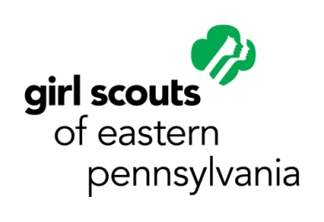

__Date__

Store Manager’s name
Name of Business
Address
City, State Zip Code

Dear Sir/Madam:

My name is ____________________________. I am in ____ grade at ________________________ and a Girl Scout in Girl Scouts of Eastern Pennsylvania Troop # _______. I am presently working on my Gold Award, the highest award a Girl Scout can earn. For my Gold award project, I am __________________________________________, which will benefit _____________________________________________________.

In order to complete this project, I will need some materials. Perhaps you can help. The list of items that I need includes:
____________________________________________________________________.

I greatly appreciate any assistance you can provide to help make my project a success. Girl Scouts of Eastern Pennsylvania is a 501 © (3) non-profit organization. If you have any questions you may contact me at _____________________ or Maggi Miller, GSEP Manager of Service & Awards, at mmiller@gsep.org or 610-933-7555, extension 1406. Thank you.

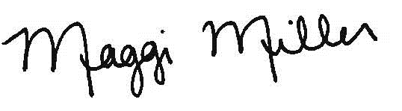
Sincerely,
Your name Maggi Miller
Your street address GSEP Manager of Service & Awards
City, State Zip Code

