Cookie Rally 2022 Activities

Station 1: Product Expertise
Cookie Lanyard & Taste Test
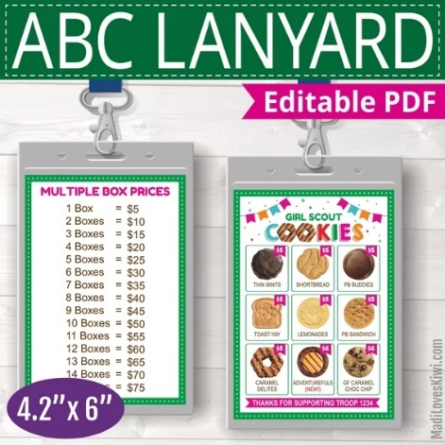
Supplies:
- Cookie lanyard printables
  - See attachment
- Cookie reference sheet
- Lanyards and holders
- Scissors
- Glue Sticks
- Markers

Directions:
- Introduce the station by asking girls why they think it’s important to know about the product they will be selling? (It’s important in order to be able to inform customers about their product and answer questions)
- Explain to girls that they will be making a lanyard with pictures of all of the cookies they will be selling so they can tell their customers about their product and how much each box costs. The lanyard will also include a price chart so girls can easily figure out how much money a customer owes if they are buying more than one box of cookies.
- Talk through each cookie and let girls discuss how each one looks and what it tastes like. See the cookie reference sheet for descriptions.
- To make the lanyards
  - First cut the printables apart and then glue the two sides together using a glue stick. Girls should then put their name somewhere on the printable using a marker. Next, have girls place their printable inside of the lanyard holder. They can either wear their lanyard for the rest of the session or put it in their bag.

Cookie Reference Sheet

Peanut Butter Patties: Crispy vanilla cookie layered with peanut butter and covered in chocolate. It is also one of our vegan cookies.
Lemonades: Shortbread cookie with a tangy lemon flavored coating. It is also one of our vegan cookies.
Chocolate Chip Trios: Gluten free chocolate chip cookie. These cost $5 per package.
Caramel Delights: Vanilla cookie coated in caramel, sprinkled with toasted coconut, and laced with chocolatey stripes.
Shortbread: Traditional shortbread cookie.
Peanut Butter Sandwiches: Crisp and crunchy cookies with creamy peanut butter filling.
Thin Mints: Crispy chocolate wafers dipped in a mint chocolate coating. It is also one of our vegan cookies.
Toast-Yays: French Toast-inspired cookies dipped in delicious icing and stamped with the trusted Girl Scouts’ signature trefoil on top.
Adventurefuls: The newest Girl Scout cookie, brownie-inspired cookie with caramel-flavored crème and a hint of sea salt.

Station 2: People Skills

Thank You Cards
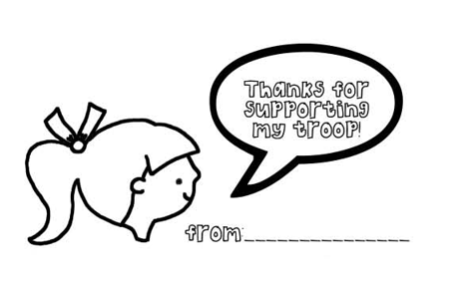
Supplies:
- Thank you card pintables
  - See attachment
- Scissors
- Colored pencils

Building on customer interactions, make thank you cards that can be handed out . Customers will never forget this thoughtful gesture when they come back next year!
Directions:
- Introduce the station and ask girls who our customers are when we are selling cookies? (Answers will vary)
- Ask girls is they know what customer service is? Then, tell girls that customer service is the support you provide to your customers. It may mean answering their questions, helping them find a cookie flavor they will like, or thanking them for purchasing cookies.
- Talk to girls about why customer service is important when selling cookies and ask them what ways they think they can provide good customer service during the upcoming cookie sale.
- Say: One thing we can do to thank our customers and encourage them to buy cookies from us next year is giving them a thank you note. Today we are going to create some thank you cards that you can take with you and hand out to customers.
- Give each girl 2 sheets of thank you cards, have them fill in either their name or troop number on each card. They can then cut them apart and place them in their bags for safe keeping.

Station 3: Decision Making
Cookie Booth Role Play
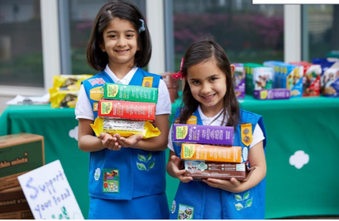

Supplies:
- Table cloth
- Cookie boxes
- Fake money
- Sign with troop number
- Money box
- Chart Paper
- Masking Tape
- Markers
*May need to ask some of the adults accompanying the girls to act as “customers” or “cookie bosses”
Directions:
- Welcome the girls to the station and ask them what they think makes a “good” cookie booth. Write down their suggestions on a piece of chart paper.
If the girls are having a hard time coming up with ideas, suggest from this list:
- Table Cloth on Table
- Cookie Varieties Neatly on Display
- Signs with: troop #, troop goals, cookie prices
- Girls wearing GS uniform/shirt with GS pin
- Girls & Adults dressed neatly
- 2 adults and minimum of 2 girls working the booth
- Booth is nicely decorated
- Adult is keeping money secure
- Girls are interacting with customers
- Girls are smiling
- Girls are asking customer if they want to purchase cookies
- Girls are collecting money and handing to adults

- Show the girls the “Worst” booth skit.
Your Set: Have a table set up with no table cloth, with cookies just thrown on the table messily, display no signs/signs with no information, trash, and have cash “tin” in plain sight and open on the table.
Your Skit: Have yourselves and volunteers acting as girls selling cookies, adult chaperones, and some customers. Model “bad behavior” such as:
Adult sitting on a chair on her cell phone, not paying attention to the girls or customers.
Girls playing hand games or with a ball, not engaging with customers.
Everyone walks away from the table at one point and come back with the cashbox taken by a customer.
Girls forgetting to ask customers to buy cookies, or mumbling, not making eye contact, not saying “thank you” to customers.
- Once the skit is over, ask them to suggest the things they see that are wrong.
If they need help, point to their idea of a “good” cookie booth and ask what’s missing.
If time allows, have the girls to work as a team to turn the “WORST” booth into the “BEST”!

Station 4: Goal Setting

Koala Goal Tree
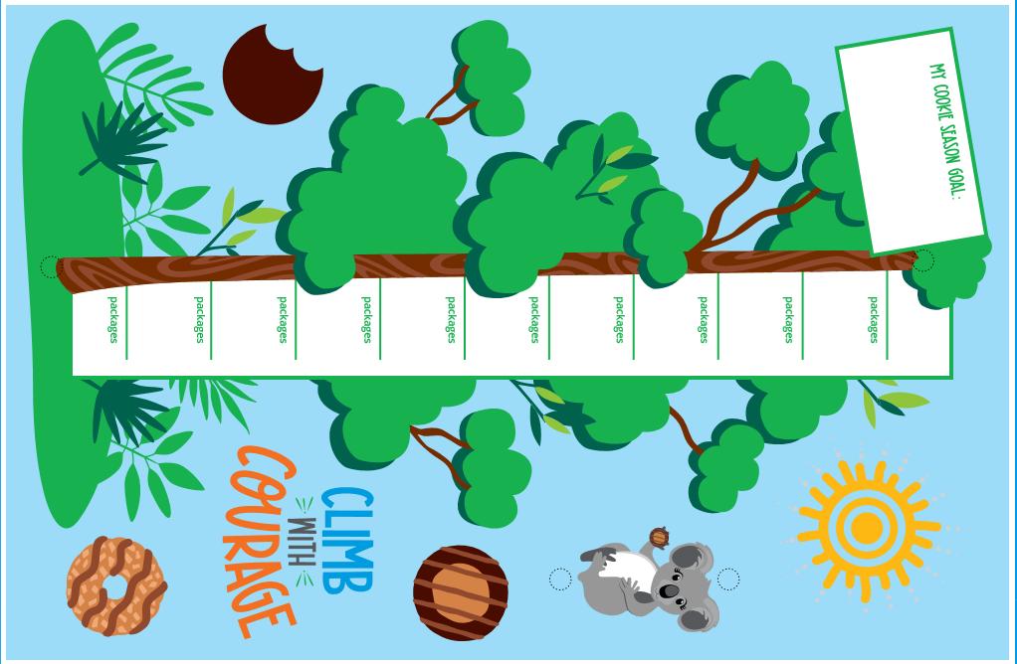
Supplies
- Koala Goal Tree Printable
  - See attachment
- 8.5″x11″ cardstock
- pipe cleaners- brown
- scissors
- clip art
- hole punch
- tape or glue stick
- markers
Directions:
Step 1: Print and cut out the template and clip art.
Step 2: Write your package goals on the lines provided.
Step 3: Write your cookie season goal at the top of the tree. This can be what you want to learn this year, what you want to do with your troop or your cookie earnings.
Step 4:Tape or glue all of the template and clip art pieces onto a colorful piece of 8.5″x11″ cardstock. Save the koala clip art for steps 6 and 7.
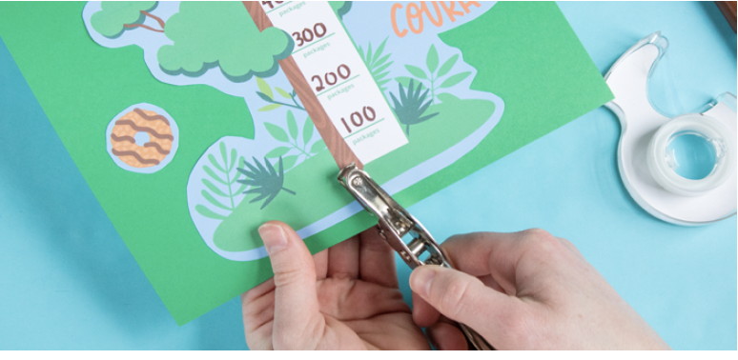
Step 5:
Punch a hole at the top and bottom of the tree.
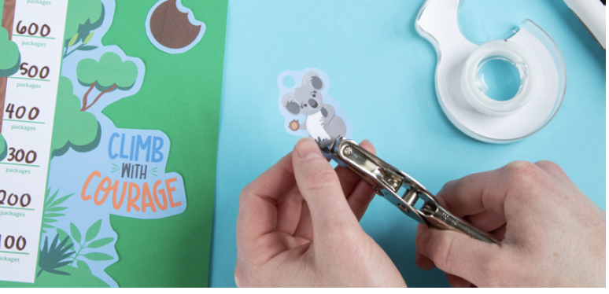
Step 6:
Punch a hole in the circles marked above and below the koala clip art.
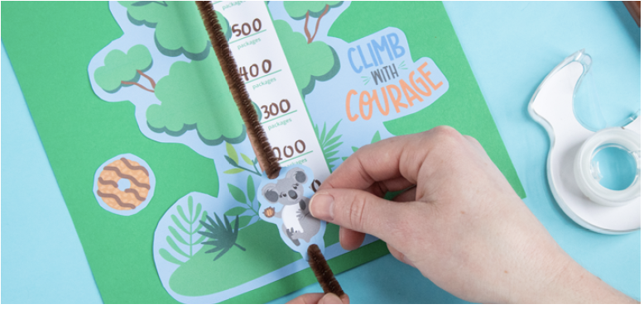
Step 7:
Slide a pipe cleaner through the holes at the top and bottom of the koala clip art.
Step 8:
Slide the pipe cleaner through the hole at the top of the tree.
Tip: It helps to tape or bend the pipe cleaner on the back side of the cardstock to hold it in place.
Step 9:
Repeat step 8 for the hole at the bottom of the tree.
Step 10:
Have girls slide the koala up the tree as she climbs closer to each of her cookie season goals.

Station 5: Money Management
Roll the Dice

Supplies:
- Dice
  - 1 to roll as boxes to be purchased, 1-6
  - 1 to roll to see how much $ the customer is handing you
- Fake Money
- Cookie/Price chart

Directions:
- Welcome the girls to the station and explain that they’re going to learn about managing money while selling cookies.
- Show the girls the cookie/price chart which breaks down how much money a customer will need to pay for cookies, depending on how many boxes they want.
- Explain the game:
  - Roll the first die to find out how many boxes of cookies their customer wants to buy.
  - Roll the second die to find out how much money your customer is handing you.
    - If it’s less than the amount needed to pay for all the boxes, the girl must figure out how much is still owed
    - If it’s more than the amount needed to pay for all the boxes, the girl must figure out how much change to give
  - Note: Daisies and some Brownies may need help with the math. They can use the cookie/price chart as a reference.
Station 6: Cookie Recognitions

Supplies:
- Cookie recognition sheets to give to the girls
  - See attachment

Directions:
- Tell girls that because they will be selling Girl Scout cookies they have the opportunity to earn recognitions. Explain that depending on how many boxes of cookies they sell they can earn different items- that is what goal setting is helpful!
- Show each of the items, tell girls how many packages they need to sell to earn the item and pass the item around so girls can see the recognitions.
- Explain to girls that they should share their goals with their customers so they know what they are working toward.
- After going through all of the recognitions ask the girls these questions:
  - What is your favorite item?
  - What can you do to help you reach your cookie selling goal?
  - What skills do you think you will learn from participating in the cookie program?

Master Supply List:

Cookie lanyard pintables
Cookie reference sheet
Lanyards and holders
Glue Sticks
Markers
Thank you card pintables
Scissors
Colored pencils
Table cloth
Cookie boxes
Fake money
Sign with troop number
Money box
Chart Paper
Masking Tape
Koala Goal Tree Printable
8.5″x11″ cardstock
pipe cleaners- brown
hole punch
Tape
Dice
Cookie/Price chart
Sample of all of the recognitions
Cookie recognition sheets to give to the girls

