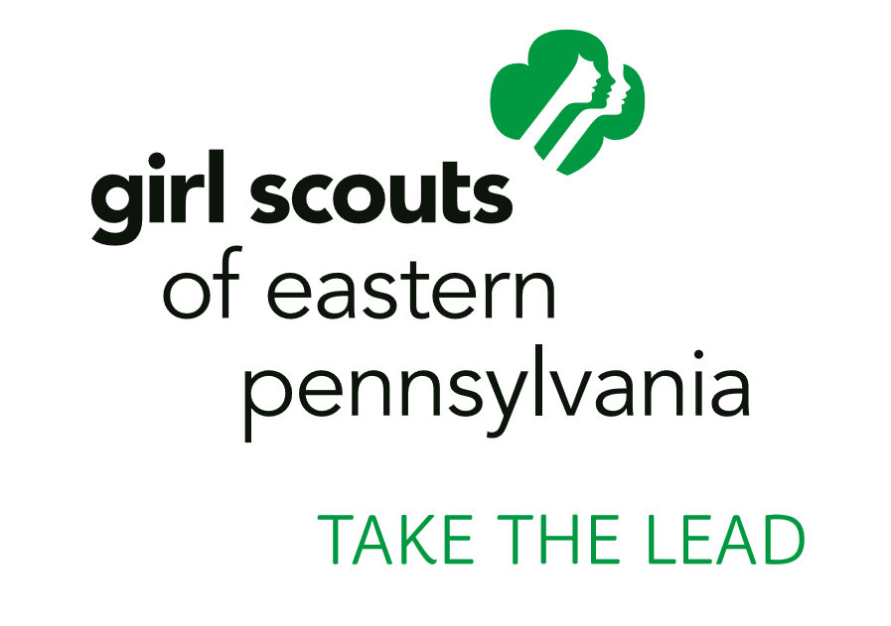
For more information, contact:
Vicki Lupica
Girl Scouts of Eastern Pennsylvania
267.322.1446
vlupica@gsep.org

GIRL SCOUTS OF EASTERN PENNSYLVANIA ANNOUNCE 2021 TAKE THE LEAD PROGRAM
The girl-serving organization paired women leaders from Greater Philadelphia, Berks County, and Lehigh Valley
with local high school-aged Girl Scouts to forge long-lasting, valuable mentorships

mIQUON, PA (January 28, 2021) — Girl Scouts of Eastern Pennsylvania (GSEP) announced its annual Take the Lead program, premier fundraiser for the council, and a unique leadership program that fosters mentorships with distinguished women leaders from the community whose work and achievements make the world a better place.

Through the Take the Lead program, high school-aged Girl Scouts have the opportunity to shadow inspiring women leaders from the Greater Philadelphia, Berks County, and Lehigh Valley area for a day to gain valuable insight into their careers and help them jumpstart their professional networks.

“Our 2021 Take the Lead honorees have changed the world for the better, and serve as incredible role models for our girls. The Take the Lead event raises critical funds for Girl Scouting in Eastern Pennsylvania and is more important this year than ever before. Event Co-Chairs and Committees work tirelessly to help raise money to sustain Girl Scouting in every community, and to ensure that every girl has access to our leadership program no matter her circumstance,” said Kim E. Fraites-Dow, Chief Executive Officer of GSEP. “Our Girl Scouts, as they always are, will be the stars of the show serving as hosts and presenters of awards to our fantastic honorees, with whom they form relationships through significant mentoring and training events. Each Take the Lead Honoree inspires the girls and other attendees to serve our community with courage, confidence, and character, and to take action individually and collectively to make the world a better place.”

Thirteen Girl Scouts across nine counties were selected by the council to be paired with the thirteen Take the Lead Honorees.

2021 Take the Lead Greater Philadelphia – March 2
Presenting Sponsor: PECO
Co-Chairs:
Jackie Cuddeback, Vice President, Partnership Sales and Corporate Marketing, Philadelphia Phillies
Hilary Hannan Saylor, Associate, Stradley Ronon

Honorees:
- Dona File, M.S., Corporate Safety Director, L.F. Driscoll
- Nicole Marquis, Founder, and CEO, HipCityVeg
- Dr. Charmaine Spence Rochester, DHA, CPA, FACHE, FHFMA, Chief Financial Officer, Penn Medicine Lancaster General Health
- Leslie Stiles, President, Pennsylvania Conference for Women
2021 Take the Lead Berks County – April 6
Co-Chairs:
Karen Marsdale, Senior Vice President, Greater Reading Chamber Alliance, Ret.
Michele Richards, Director of Treasury Sales, Fulton Bank

Honorees:
- Susan Denaro, Attorney, Georgeadis Setley
- Kristin Boyd Edwards, Communications Director, Reading School District
- Jacquelyn Fetrow, Ph.D., President, Albright College
- Debra Powell, MD, Chief, Division of Infectious Diseases and Medical Director, Infection Prevention, Tower Health Reading Hospital
2021 Take the Lead Lehigh Valley – April 28
Presenting Sponsor: Olympus Corporation of the Americas
Chair: Stephanie Sherry, Vice President, Corporate Communications, Olympus Corporation of the Americas

Honorees:
- Lisa Boscola, State Senator, 18th District
- Victoria Brifo, Senior Vice President and Chief Human Resources Officer, Air Products
- Fusun Bubernack, President, ET&T
- Lin Erickson, Executive Director and CEO, Da Vinci Science Center
- Deborah Sundlof, DO, Cardiologist, Lehigh Valley Heart Institute

For more information about the Take the Lead program and sponsorship opportunities and benefits, events tickets, and other opportunities to support, please visit www.gsep.org/takethelead or email takethelead@gsep.org.

About Girl Scouts of Eastern Pennsylvania
Girl Scouts of Eastern Pennsylvania (GSEP) is the largest girl-serving organization in Pennsylvania and builds girls of courage, confidence, and character, who make the world a better place. GSEP serves close to 40,000 girls in partnership with more than 15,000 volunteers in Berks, Bucks, Carbon, Chester, Delaware, Lehigh, Montgomery, Northampton and Philadelphia counties. Today, 80 percent of women in leadership and executive roles in the U.S. were Girl Scouts. Girl Scout alum comprise 70 percent of women in the U.S. Congress. For further information about Girl Scouting, how to join, volunteer, reconnect, or donate, call 215-564-2030 or visit www.gsep.org.

Follow @GirlScoutsEPenn on Twitter and Facebook!
###

