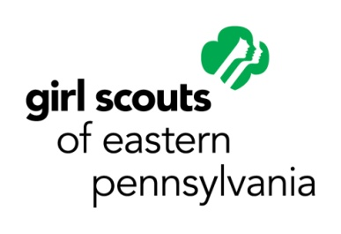

Letter for Solicitation of Materials
Girl Scout Silver Award

Girls wishing to solicit donations of supplies from businesses and organizations for their Silver Award project must complete and use this form to do so.

Important Reminders:
- This letter can be found on GSEP’s Silver Award webpage: http://www.gsep.org/en/about-girl-scouts/our-program/highest-awards/silver-award.html
- Review the entire letter. Fill in all the blank spaces and remove all extra lines underlining the text.
  - Be sure to list the quantity and size of the items you are requesting, if applicable.
  - Be sure to also add your signature, typed name, and address to the bottom of the letter.
  - Do not revise any other section of the letter.
- Please only use this form to request donations of supplies needed for your project.
  - Note that you cannot seek or accept cash donations from the general public. Do not use this form to ask for donations of cash.
  - You also cannot request donations of gift cards; however, you may accept gift cards if they are offered to you.
- Before submitting to the business, review your completed letter for spelling mistakes, grammar mistakes, and general editing. If possible, ask another person to help proofread the letter.
- Keep a copy of each letter you use and include it with your Silver Award Project Visual Aid that you will turn in at the end of your project (along with your Reflection).

__Date__

Store Manager’s name
Name of Business
Address
City, State Zip Code

Dear _____________:

My name is ____________________________. I am in ____ grade at ________________________ and a Girl Scout in Girl Scouts of Eastern Pennsylvania, Troop # _______. I am presently working on my Silver Award, the highest award a Girl Scout Cadette can earn. For my Silver Award project, I am ____________________________________________, which will benefit __________________________________________________.

In order to complete this project, I will need some materials. Perhaps you can help. The list of items that I need includes: __________________________________

I greatly appreciate any assistance you can provide to help make my project a success. Girl Scouts of Eastern Pennsylvania is a 501(c)(3) non-profit organization. If you have any questions you may contact me at _____________________. Should you need to contact GSEP, please contact Hana Haseman, Director of Camps, Family Initiatives and Special Programs, at hhaseman@gsep.org or 267-332-4894. Thank you.
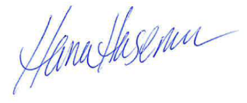
Sincerely,

Your name Hana Haseman
Your street address Director of Camps, Family Initiatives and Special Programs City, State Zip Code

