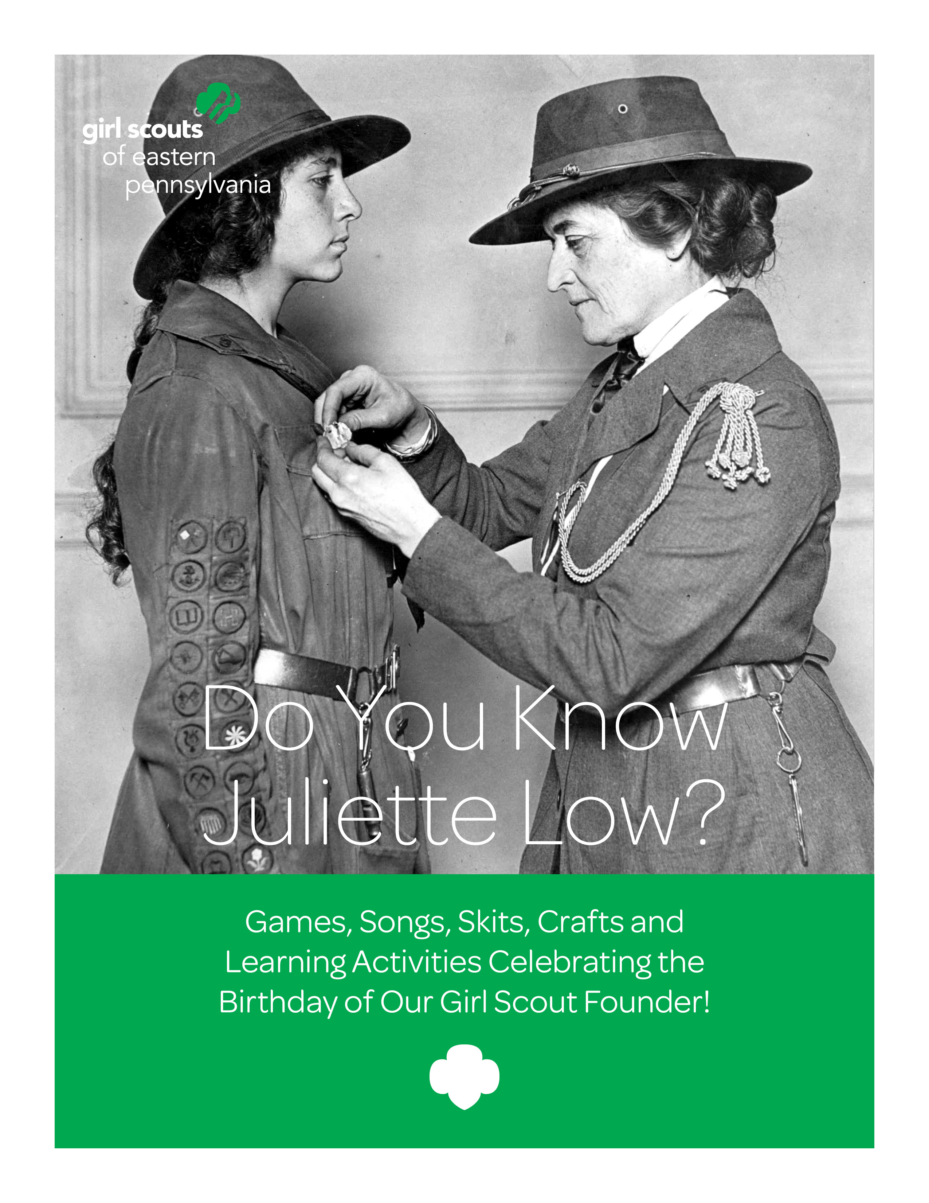

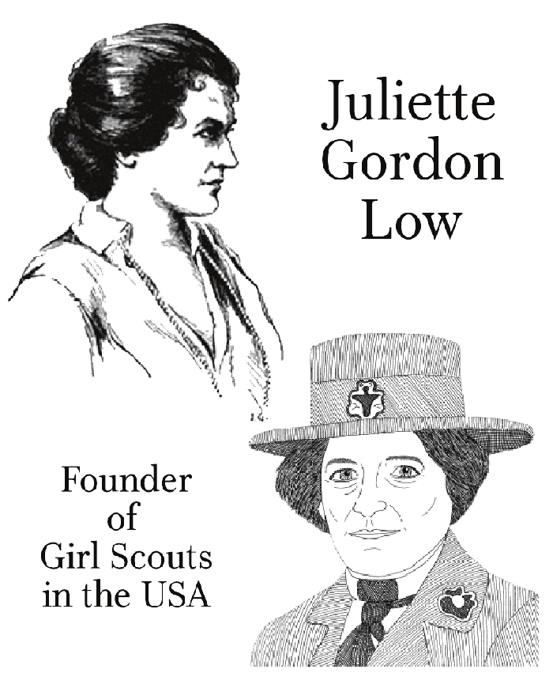
Coloring Page

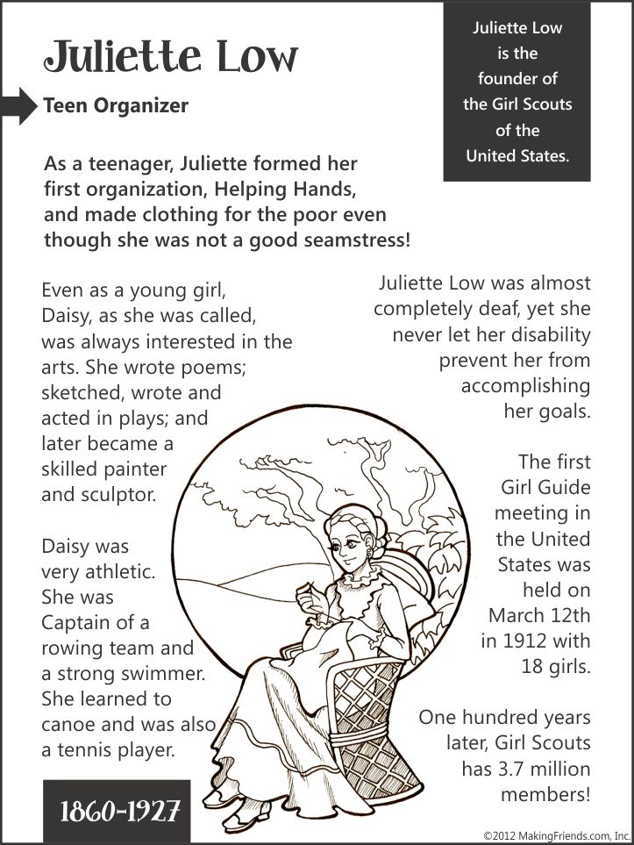
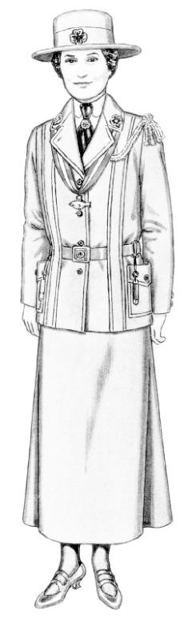

“Flat Juliette Low”

Flat Juliette Travels
Send Flat Juliette to friends and family in other areas. Ask them to send her back with an entry in her journal page and photos of the places she went with them. Create a scrapbook of her travels.

Here are some questions you can answer:
• What town in what state (or country) did Juliette visit?
• Who was in the family she visited? What are their and ages?
• Did she meet anyone else while she was there?
• What did she do while she was there? Did she visit any local sites or events?
• What did she eat?
• What was the weather like? (You can give Juliette an umbrella if it’s rainy, or sunglasses if it’s bright and sunny)
• Did she learn any words in a different language?

Daisy Low Story-Game for Girl Scout Daisies

Leader: “Listen closely while I tell you the story of Juliette Gordon Law, who started the American Girl Scouts. Every time I say Mrs. Low‘s nickname, “Daisy” YOU have to say ‗”We‘re Daisies too!”
Let‘s practice.
(Say “Daisy” and let girls reply.)

STORY:
―Once there was a girl named Juliette Low who lived in Savannah, Georgia. Her nickname was Daisy. Daisy was an artist, but she also loved pets, playing outdoors, and helping others. When Daisy grew up and got married, she moved to England, where she met Lord Baden-Powell, who started the Boy Scouts and Girl Guides. Lord Baden-Powell told Daisy about the Girl Guides, and she decided to become a leader. Daisy liked Girl Guiding so much, she wanted to share it with her friends and family in Savannah. So Daisy said good-bye to the Girl Guides in England and took the ideas that Lord Baden-Powell gave her home to Georgia. There Daisy formed a group of girls who loved animals, art, the outdoors and helping others. These American girls called themselves Girl Scouts instead of Girl Guides, but they were still part of the same world-wide family. So aren‘t you glad that
[speed up here]
Juliette Low from Savannah, Georgia,
Who was an artist and loved the outdoors,
went to England and met Lord Baden-Powell,
Learned about the Girl Guides,
and came home to start the Girl Scouting in the USA
where the youngest Girl Scouts are called Daisies!‖

Daisy Low Story—Game for GS Brownies and Juniors
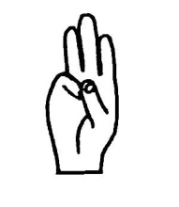
Leader: ―Girl Scouts was started in 1912 by a woman named Juliette Gordon Low. Listen closely while I tell you her story, because you’re going to make sound effects and do the actions for the story!
―Whenever I say “JULIETTE” - you wave and say, ‗”Daisy”!‖ [practice]
―If I say “GIRL GUIDES/GUIDING or GIRL SCOUTS/SCOUTING” - you give the Girl Guide/Girl Scout sign [demonstrate] and say, ―”Be prepared”!‖ [practice]
―And if I say “WORLD” - you spin around once and say ‗”Wheeee!”‖ [practice]

―Remember: Juliette – wave and say ‗Daisy; Girl Guides or Girl Scouts, make the Girl Scout Sign and say ‗Be prepared; and when I say world, spin around and say ‗whee!

STORY: ―A long time ago, there was a lady from Savannah, Georgia, whose name was JULIETTE GORDON LOW. Her family and friends all called her Daisy. Daisy was an artist, but she also loved riding horses, putting on plays, and helping others. When JULIETTE grew up and got married, she moved to England, where she learned about GIRL GUIDING from her English friend Lord Baden-Powell [“BAY-den pole”] who had also started the Boy Scouts. JULIETTE Low became a GIRL GUIDE leader in Scotland and in London. She had so much fun, she wanted to tell the girls in Savannah and all of America and all the WORLD, about GIRL GUIDING! JULIETTE started her first troop in America on March 12, 1912, with 18 girls – but soon there were thousands of members! American girls decided they wanted to be called GIRL SCOUTS and JULIETTE agreed - but even with different a name, GIRL SCOUTS are still part of the same WORLD family. JULIETTE Low thought GIRL SCOUTING and GUIDING was such a fine thing, she wanted to see troops all over the WORLD. She knew GIRL GUIDING AND SCOUTING would help girls from different countries become friends and would help build WORLD peace and understanding. So aren‘t you glad that [speed up here] JULIETTE Low from Savannah, Georgia, who was an artist and loved the outdoors, went to England and met Lord Baden-Powell, learned about the GIRL GUIDES, and came home to start the GIRL SCOUTS in Savannah, Georgia in 1912!

Juliette Low's Birthday Game

This Birthday game can be played outside or inside when the weather does not permit.

Starting Point: Each patrol of girls receives a note saying Juliette Low started Girl Scouting in Savannah by telephoning a friend. The first clue will be by the telephone.
1st Point: The first clue told them where to find a person with a daisy. That person also has a paper pumpkin. Say "Juliette Low was born on Halloween, so draw a nose, mouth, or eyes to start a Jack-o-Lantern." Then show the girls where the trail, marked with paper pumpkins, starts and tell them to follow it.
2nd Point: At the end of the pumpkin trail will be an adult. Tell them that Juliette Low liked to put on plays. Ask the girls to choose and act out a Halloween character. When you guess what they are acting out, make a trail sign to show the team which way to go. (To make a trail sign, use leaves, twigs, etc. to make an arrow in the direction they need to go OR use a branch to mark in the dirt; have this ready, but perhaps covered up with a paper.)
3rd Point: At this point, there will be an adult dressed as an Native American Indian. Tell them that Juliette Low's grandmother was captured by Indians and lived with them. Her Indian name was Little-Ship-Under-Full-Sail. If the girls can tell you which way is north by looking at the sky (sun/moon), the Indian will give them a sketch map to the next point.
4th Point: The map leads the girls to a person with an American flag. She says that the first handbook was called "How Girls Can Help Their Country". She asks them to tell her two ways a Girl Scout can be a good citizen on a hike. Then ask them to fold the flag. Then direct them to a trail marked with red ribbons.
5th Point: At the end of the red ribbon trail, meet the team and say that Juliette Low has friends all over the world. Ask the girls to show how they would greet a Girl Guide from another country. Then she says that Juliette Low camped with many girls and was a good storyteller.
THE END…

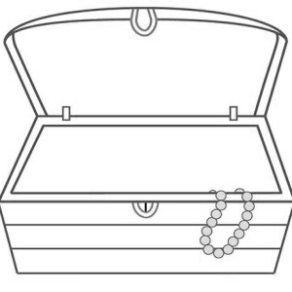

Quick Ideas for Daisy’s Day:

• Play old-time games—hopscotch, blind-man‘s buff, and other games from the Victorian era (Daisy‘s days!)

• Embroider a daisy flower using an outline or cross-stitch.

• Traditional cooking--make butter with a churn and eat it with warn corn bread; talk about homemaking in the 1860s, when Daisy was a girl.

• Use the arts to give service—create handmade cards to go to a nearby Veteran's hospital or collect donations such as socks or canned goods to be donated at a food pantry. Each girl could bring one item for a birthday party (cake mix, icing, plates, etc.) and donate to a shelter for homeless families.

• Biography—act out key events from Daisy‘s life.

• Hide ―pearls‖ around your meeting place and have a pearl hunt by individuals or in teams; older girls could create a treasure hunt for the pearls and exchange clues with other teams.

• Create a giant puzzle of Juliette Low; cut up the picture and hide the puzzle pieces around your meeting place. Girls or teams have to find pieces and reassemble puzzle.
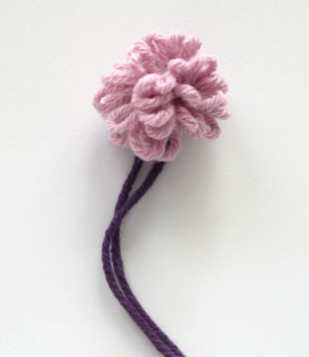
DAISY CRAFT: “Fork Daisies” (http://www.crochetgarden.com/crochetblog/?p=74)
Needed Items:
Fork to use as a loom – metal or heavy duty plastic, Various colors of yarn, and Scissors

- Cut a piece of yarn 6 inches long and place between the middle tines of a fork so that both ends hang down. Hold fork handle and yarn together in one hand. This will become the stem of the flower after being used to tie the weaving together.

- Cut a piece of yarn 12-18 inches. Hold one end of this piece of yarn in same hand along with fork and stem piece. Begin weaving yarn in and out of the tines of the fork, weaving under one, over the next. Go around the end and continue weaving until the yarn is all used or the fork is full.

- Have a buddy help by holding the fork so you can lift the ends of the stem pieces and tie around the weaving using a half knot in the center tine. Gently pull weaving off the fork, tightening the knot as you pull. When knot is off the fork, tighten fully and finish the knot as a square knot.

- Trim ends even, leaving stem longer.

WHY NOT TRY…

• Create a bouquet of fork daisies in various colors. Place in a vase or pin to yourself as a corsage.
• Decorate a sweatshirt or T-shirt by pinning flowers all over with safety pins. Remove before washing as the flowers do not wash well.
• Decorate headbands, hair ties (rubber bands will break easily), barrettes.
• Tie to ends of small branchy twigs. Place twigs in a baby food jar that can be decorated in a variety of ways. You can place a ball of clay in the bottom of the jar to anchor the twigs.
• Make a Daisy magnet. Use yellow poster board die-cut (your elementary school probably has a die-cut machine, very quick to do), and glue or tie a yarn fork daisy in the center. Glue a magnet to the back.

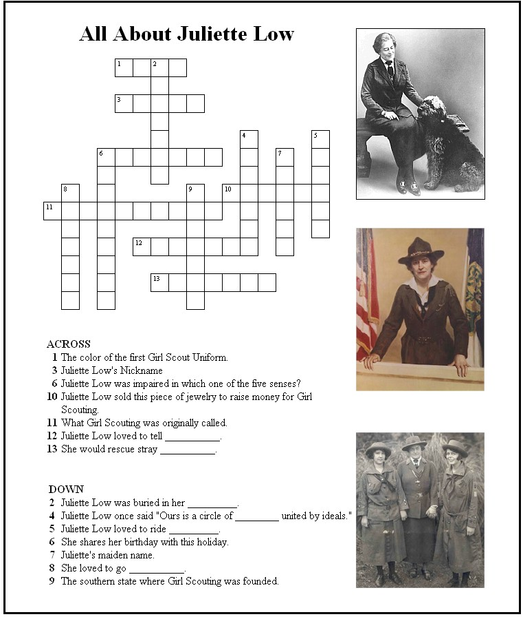

Answers
Across:
1.Blue
3. Daisy
6. Hearing
10. Pearls
11. Girl Guides
12. Stories
13. Animals

Down:
2. Uniform
4. Friends
5. Horses
6. Halloween
7. Gordon
8. Fishing
9. Georgia

“DAISY” SING-ALONG

Hurrah for Daisy
(To the tune of ―My Darling Clementine‖)
Long ago in London England
Daisy Low met Baden-Powell
Started planning hard for scouting
Where we all are members now
CHORUS: Hurrah for Daisy
Hurrah for Daisy
Hur-rah for Daisy Low
Started Girl Scouts in our country
In Savannah, long ago
Took us camping
Taught us cooking
Working hard for me and you
Set a trail and set the table
Are some things we learned to do
(Chorus)
As a Daisy,
Brownie, Junior
In Cadettes and Seniors too
Even as Girl Scout Ambassadors
We will keep our Promise true
(Chorus)

Juliette Gordon Low (tune: ―Twinkle, Twinkle Little Star‖)
Chorus: Juliette, Juliette Gordon Low
Founded the Girl Scouts long ago
From Savannah she did roam
But she always called it home
(Chorus)
Married a man named Willy Low
And off to England they did go.
There she met Lord Baden-Powell
Starting the Boy Scouts was his goal
When she came back to the USA
She called her cousin right away
She Founded the Girl Scouts in 1912,
Served her country, served it well
(Chorus)
Girl Scouts she came here to start
And I thank her from my heart.
Thank you, thank you, Daisy Low
For starting the Girl Scouts long ago!

Daisy
(sung to the tune of ―A Bicycle Built for Two‖)
Daisy, Daisy,
We honor your mem‘ry true.
We are Girl Scouts,
All because of you.
We follow the path you started,
And live the law you charted.
We grow and grow
Dear Juliette Low,
America‘s proud of you!

Craft: Girl Scout Law Wall Hanging

Method 1: Cut up and glue each law onto individual craft sticks or pieces of cardstock. Connect the laws with strips of ribbon, yarn, string or cardstock. Finish with ribbon, yarn, or string for hanging. Method 2: Glue alphabet pasta on craft sticks and finish as described above.
THE GIRL SCOUT LAW
I WILL DO MY BEST TO BE. . .
HONEST AND FAIR
FRIENDLY AND HELPFUL
CONSIDERATE AND CARING
COURAGEOUS AND STRONG
RESPONSIBLE FOR WHAT I SAY AND DO
AND TO RESPECT MYSELF AND OTHERS
RESPECT AUTHORITY
USE RESOURCES WISELY
MAKE THE WORLD A BETTER PLACE, AND
BE A SISTER TO EVERY GIRL SCOUT

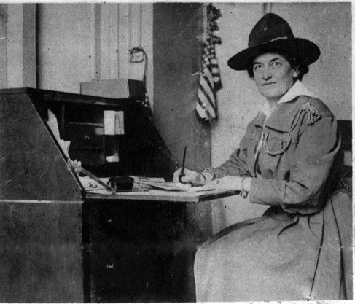

How Well Do You Know Juliette Low…QUIZ

- Juliette Gordon Low started the Girl Scouts when she was _____ years old.

- 31
- 43
- 51
- 53

- To show how young she was, on her birthday Juliette Gordon Low, better known as Daisy, liked to….

- Hike 6 miles around Tybee Island, just off the coast of her hometown of Savannah Georgia, stopping just once—for a picnic lunch.
- Walk around Savannah’s Bonaventure cemetery just before midnight, dressed in her Girl Scout uniform.
- Stand on her head
- All of the above

- Which of the following are NOT true?

- Juliette Gordon Low was known to dislike jokes and humor.
- Juliette Gordon Low was an accomplished ragtime pianist.
- All of the above
- None of the above

- Juliette Gordon Low was honored with a three-cent commemorative stamp on Oct. 29, 1948, just two days before what would hae been her ____ Birthday.

- 87th
- 88th
- 89th
- None of the above

- After attending boarding school in Virginia, Juliette attended:
- A French finishing school in Washington, D.C.
- A French finishing school in New York City
- A German finishing school in Savannah, Georgia
- A French finishing school in Atlanta, Georgia

Answers:

- C
- C
- D
- B
- B

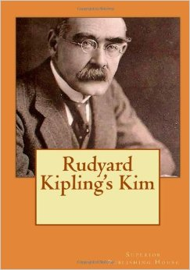
DAISY LOW “KIM’S GAME”

Kim's Game is an observation and memory game played by Boy Scouts, Girl Scouts and Girl Guides. The name is derived from Rudyard Kipling's 1901 novel Kim, in which the hero, Kim, plays the game during his training as a spy. The training involved showing Kim a tray of stones and gems for one minute. After covering the tray, they would ask Kim how many stones he saw and what kind of stones they were. Rudyard Kipling was a good friend of both Robert Baden-Powell, founder of the Boy Scouts and Girl Guides, and Juliette Low, founder of the Girl Scouts (USA.)

Directions:
The objects used in a Kim‘s Game can be chosen to reflect a theme: nature, first aid, knots, or…Girl Scout history! As you tell the story below, you will need the items in bold (or something similar) to hold up for the girls to see. At the end of the story, cover all the items with a towel and see how many the girls can remember.

LEADER:
Juliette Gordon Low was the founder of Girl Scouting in the United States. I‘d like to tell you a little about her life:

-Juliette Gordon was born in Savannah, Georgia, on October 31, 1860 – Halloween! (Hold up toy or small pumpkin/jack-o-lantern)

-When her uncle saw baby Juliette, he said, “I bet she‘s going to be a daisy!” and the nickname stuck with her the rest of her life. (Hold up artificial daisy)

-Daisy loved to play outdoors, to run and swim and climb trees. And she always loved animals, especially dogs and horses. (Show toy horse or dog)

-She also loved to make up plays and to draw and paint pictures. When her cousin made a magazine by children, for children, Daisy wrote most of the Volunteer Learning & Development Knowledge Management May 2013 Girl Scouts of Greater Atlanta stories and painted most of the pictures. (Show water color paint brushes markers, or crayons.)

-After Daisy finished school, she traveled in Europe, where she met a handsome Englishman named Willy Low. Daisy and Willy got married in Savannah in 1886. (Hold up wedding rings or bell)

-Some of the rice thrown at their wedding became lodged in Daisy‘s ear. It got infected and Daisy lost her hearing in that ear. (Show baggie of rice.)

-Daisy had lost the hearing in her other ear as a teenager, and now she was almost totally deaf. Daisy and Willie lived in England and Scotland for many years. After Willie died, Daisy traveled to other countries, taking her nieces and nephews and their friends with her. (Hold up sail boat or cruise ship.)

-But Daisy wanted to do more with her life. Back in England, Daisy met Lord Robert Baden-Powell and his sister, Agnes. They told her about the Boy Scouts and Girl Guides they had started.(hold up old book labeled Scouting)

-Daisy wanted the girls in the United States to have the fun of being Guides too, so she returned to Savannah and made a famous phone call to a friend: ―Come right over! I‘ve got something for the girls of Savannah and all America, and we‘re going to start it tonight. (Hold up telephone.)

-On March 12, 1912, Juliette Gordon Low started the first American Girl Guide group with 18 girls. Today there are 3 million American Girl Scouts, and we celebrate March 12 as the Girl Scout Birthday. (Hold up calendar with March 12 circled)

-Daisy thought the name ―Scouts suited American girls better, so she soon changed the name from Girl Guides to Girl Scouts. It took a lot of money to get the Girl Scouts started, so Daisy sold the pearl necklace Willy had given to her as a wedding present. (Hold up pearls.)

-The first American Girl Scout handbook showed girls how to tie up a burglar using 8 inches of rope! (Hold up a small piece of rope)

-Daisy once said that (hold up gold thread or ribbon) that Girl Scouting and Guiding could be the golden thread that linked the girls of the world together.

When Daisy lived in England, she made friends with Rudyard Kipling, the author of The Jungle Books. Mr. Kipling taught the Scouts and Guides how to play an observation and memory game from another one of his books, Kim. We‘re going to play a Kim‘s Game about Daisy Low now.

*For older Girl Scouts: Divide the girls into team of 3 or 4 and give them a sheet of paper and a pencil. They have 3 minutes to list as many of the items shown during the story as they can remember. Uncover the items and let everyone compare their list to what’s there. Ask them what part of Daisy’s story was connected to each item.

*For younger Girl Scouts: Ask the girls to call out all the items they remember while you write them down; then compare your list to what’s under the sheet or cover. Ask the girls to close their eyes; remove one item and hide it; ask the girls to name which item you removed.

