Letter for Solicitation of Materials
Girl Scout Silver Award

Girls wishing to solicit donations of supplies from businesses and organizations for their Silver Award project must complete and use this letter to do so.

Important Reminders:
- What can you request donations of supplies and how?
  - Use this letter.
  - You cannot ask for or accept cash donations from the general public.
  - You cannot request donations of gift cards; however, you may accept gift cards if they are offered to you.
- Review the entire letter.
  - Fill in all the blank spaces and remove all extra lines underlining the text.
  - Be sure to list the quantity and size of the items you are requesting, if applicable.
  - Add your signature, typed name, and address to the bottom of the letter.
  - Do not revise any other section of the letter.
  - Check your letter for spelling and grammar.
    - It’s always a good idea to ask another person to proofread the letter.
- The tax ID for GSEP is 23-1352309, if a business requests it.
- Keep a copy of each letter to include in your Silver Award Project Visual Aid as part of your Final Report.

__Date__

Store Manager’s name
Name of Business
Address
City, State Zip Code

Dear _____________:

My name is ____________________________. I am in ____ grade at ________________________ and a Girl Scout in Girl Scouts of Eastern Pennsylvania, Troop # _______. I am working on my Silver Award, the highest award a Girl Scout Cadette can earn. For my Silver Award project, I am ____________________________________________, which will benefit __________________________________________________.

In order to complete this project, I will need some materials. Perhaps you can help. The items that I need include: __________________________________

I greatly appreciate any assistance you can provide to make my project a success. Girl Scouts of Eastern Pennsylvania is a 501(c)(3) non-profit organization. If you have any questions you may contact me at _____________________. Should you need to contact GSEP, please contact the GSEP Girl Experience Team, at girlawards@gsep.org or 215-564-2030. Thank you.

Sincerely,
Your name 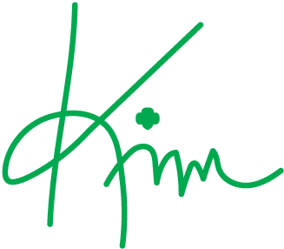
Your street address Kim E. Fraites-Dow
City, State Zip Code CEO, Girl Scouts of Eastern Pennsylvania

