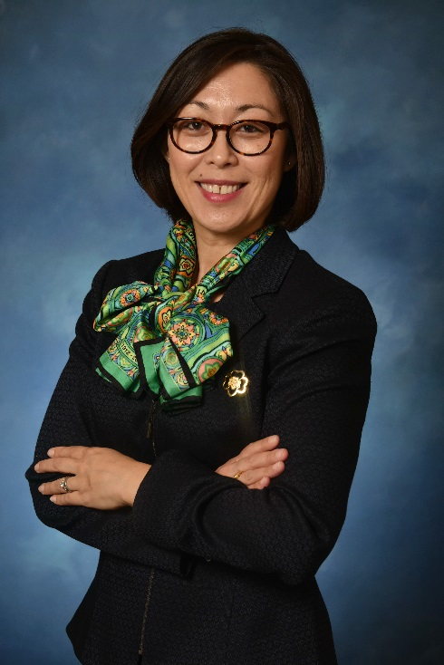
Kim E. Fraites–Dow
Chief Executive Officer
Girl Scouts of Eastern Pennsylvania

Kim E. Fraites-Dow is the CEO for the Girl Scouts of Eastern Pennsylvania, having joined in March 2011 as the Chief Development and Marketing Officer and most recently serving as COO. Kim is an executive non-profit leader with 19 years of professional experience managing operations, facilities, supply chain/inventory/product sales, personnel, partnerships, marketing, communications, and brand management, board relations, and individual, foundation, corporate, and government fundraising and relations for both world-class and mid-size non-profit institutions.

Integral to her success has been Kim’s leadership in recruiting key personnel, building collaboration across diverse teams of people, and developing relationships across GSEP’s 9-county footprint. Together with the Board, staff and volunteers, GSEP recently earned Top Ten status nationally for girl and adult membership, stabilizing membership locally during a period of national membership decline. Additionally, GSEP’s contributed revenue has increased double digit percentages during her tenure, and the organization has developed more flexibility in dealing with administrative and financial complexities.

Prior to joining GSEP, Kim served as Director of Institutional Giving and Government Relations at The Franklin Institute, increasing corporate sponsorship support by 27%, corporate special event support by 38%, corporate grants by 31%, and private foundation support by 9%, all during the economic downturn from 2008-2011. Additionally, Kim secured and stewarded multiple six and seven-figure private and public commitments for the Inspire Science capital campaign. Prior to The Franklin Institute, Kim progressed in leadership roles within the development department at The Philadelphia Orchestra, where she developed long-term partnerships and relationships that have provided her support through the years. Trained as a classical clarinetist at the Eastman School of Music, Kim also earned a Psychology degree from the University of Rochester, and holds an Arts Administration certificate from New York University.

Growing up in a military family, Kim has had the opportunity to live in East Asia, Europe, and across the United States. She currently lives in the West Mount Airy section of Philadelphia with her husband Kevin, and two children. Prior to moving to Philadelphia, Kim managed a small non-profit arts organization in NYC dedicated to providing live classical music to the underserved, where she learned the importance of balancing mission and finance, managing a board of directors, fundraising from individuals and institutions, and leading staff and volunteers. She serves on the boards of the Black Pearl Chamber Orchestra, and the Cooperative Nursery School, where she serves as the Banking Treasurer, and is a past board member of the Garces Foundation and the Asian Mosaic Fund.

