It all started with a phone call on March 12, 1912. . ."I've got something for the girls of Savannah, and all America, and all the world. . ." Juliette was off and going with the first Girl Scout troop. March 12, 2011, is the 99th anniversary of Girl Scouting. During Girl Scout Week, Girl Scouts of all ages celebrate by demonstrating courage, confidence, and character in ways that have real impact on their communities. Celebrate Girl Scout Week all week with some of the ideas listed below.

- Throw a Birthday Party

Invite friends to a Birthday Party themed Troop Meeting. Have a Girl Scout birthday cake & balloons with Girl Scout songs & games to share what Girl Scouts is all about.

- Try a new activity this week:

-Sunday, GIRL SCOUT SUNDAY Think of three different ways you can serve God or your country. Do one of them.
___ Take part in a religious service.
___ Say or sing grace at a meal.
___ Do a good deed for someone.
___ Wear your Girl Scout uniform or shirt today.
___ Spend 20 minutes in quiet reflection.

-Monday, LIVE BY THE GIRL SCOUT LAW
___ Learn what WAGGGS stands for (see www.wagggsworld.org).
___ List and locate all four World Centers on a map or globe.
___ Invite a friend to your next troop meeting.
___ Recite the Girl Scout Law to your family.
___ Read or re-read the Juliette Low story.
___ Spend time working on a Girl Scout Award
___ Take part in a flag ceremony sometime this week or research how one is performed.
___ Learn about when Girl Scouting first started.
___ Do a service project. Read a book to a young child or older person.

-Tuesday, EXPLORE THE WORLD
___ Design a future Girl Scout uniform and share it with someone.
___ Make a collage of all the places you would like to visit or have visited.
___ List careers that you would like to pursue and list why.
___ Do a science project that explores the environment.
___ Visit the GSUSA website (www.girlscouts.org) and
___ Learn about a country you would like to visit and cook/prepare something from that country.
___ Interview someone who has lived in another country. to that of the United States.
___ Interview someone who is in a career you are interested in pursuing.

-Wednesday, EMBRACE HEALTH AND SAFETY
___ Do at least 20 minutes of exercise.
___ Discuss with an adult ways to handle stress
___ Check to see if your smoke detectors and fire extinguishers are working properly
___ Eat only healthy snacks today. Stay away from foods with high amounts of sugar and salt. ___ Visit an anti-smoking, anti-drinking, or anti-drug website
___ Learn how to play a new sport. Teach someone else how to play.
___ Investigate “Sunwise” (www.epa.gov/sunwise) for sun safety tips.
___ Learn what it means to eat “organic” foods. Go to the store, buy and try something organic ___ Learn some stretching exercises and do at least three of them.

-Thursday, INNOVATIVE AND SAVVY
___ Write a poem about a place you visited.
___ Create a nature collage by using only things found in nature.
___ Teach a young child or older person a new craft or game.
___ Make a new dance to your favorite song.
___ Discuss with friends what color looks best on you.
___ Learn to tie a knot or practice the ones you already know.
___ Make a piece of jewelry and give it someone special.

-Friday, FRIENDS AND FAMILY
___ Make a scrapbook of your family.
___ Do something extra special for your family or a friend and leave them a note.
___ List three things you can learn from your friends.
___ List three things your friends can learn from you.
___ Make a friendship bracelet for someone special.
___ Be extra nice to your siblings. Do a good deed for them.

-Saturday, THE GREAT OUTDOORS
___ Learn about perennials, annuals, deciduous and coniferous plants.
___ Do a rubbing on a leaf, tree bark or any other thing in nature.
___ Take a scavenger hike. Find something in nature that starts with each letter of the alphabet. ___ Plant a vegetable, flower or herb in a pot to enjoy.
___ Identify three different plants in your neighborhood.
___ Play games outside for at least 30 minutes.
___ Learn a new outdoor activity with your family

- INVESTIGATE MANNERS AND SAYINGS FROM A DIFFERENT DECADE

-Do an activity from the 1951 Brownie Scout Handbook (or another “older” handbook). Learn how to introduce people, how to receive guest, how to serve refreshments Learn how to set the table correctly, how to wash dishes, how to make a bed Plan a party with the troop and help carry out the plans Learn how to press your hair ribbons and to iron an apron Learn how to make sandwiches, lemonade, cocoa, gingerbread, a good stew. Prepare and pack your lunch for school, a hike or a picnic Learn how to use a recipe in a cookbook Learn how to clean the stove and the refrigerator.

- DO A SERVICE PROJECT THAT GIRLS WOULD HAVE DONE
Do an activity from the 1950 Leader’s Guide (or another leader’s guide) to the Scout Program Talk about and list the services we get from the community. Discuss what Girl Scouts can do in return and let them talk about the responsibility of being good citizens. Develop an activity or project out of the above discussion Learn something about the agencies in the community that give service and what the Brownie Scout troop can do to help. List the people the girls know in their own neighborhood that they might help, old people or shut-ins or a sick child. Discuss what they might do. Plan Saturday morning play periods for the children in the neighborhood, let the girls practice in the troop games they can play or give each other ideas of things they can do to entertain the children. Visit the old folks’ home to play and sing, sometimes taking flowers or perhaps special gifts they have made. Make cakes or cookies, or candy to be given to someone or served at a party for others. Take part in any national or local Girl Scout service project that fits into the troop program. Include in troop activities any local community interest such as a home safety campaign, a Clean-Up-The-Town Week, a conservation project.

- COMPLETE REQUIREMENTS FROM THE 1920 SCOUTING FOR GIRLS BOOK
Are these steps still in use today? Which badges can these requirements be found in?

Requirements for Ranks:
1. What are the Girl Scout Promise, Laws and Motto? What must a Girl Scout do every day?
2. Demonstrate the Girl Scout sign and salute. When do Girl Scouts do these?
3. Give Pledge of Allegiance to the flag. What does the flag stand for? Show how the flag should be used.
4. What are the words of the first and last stanzas of the Star Spangled Banner?
5. Give the full name of the President of the United States; the governor of your state; the highest city or town official where you live.
6. Tie the square knot, bowline, clove hitch, and sheepshank knots and demonstrate the use of each.
7. Tell the story of one animal pet (if you have not an animal pet, tell the story of any live thing you have watched).
8. Tell four woodcraft signs.
9. Present a record that you have saved or earned enough money to buy some part of the Girl Scout uniform or insignia, or pay registration fee.

- SNACKS THAT GIRL SCOUTS WOULD HAVE EATEN IN THE PAST

“Easy, Easy Old fashioned Doughnuts”

-Ingredients: 2-4 tubes of can buttermilk or homestyle biscuits, Confectioners' sugar, Cinnamon, Granulated sugar, vegetable oil for frying, a candy/oil thermometer (optional, but VERY useful), tiny round cookie cutter, stainless steel tongs, cookie sheets lightly sprayed with cooking spray, paper towel, plates

-Directions: Remove biscuits from tubes and place on sprayed cookie sheet. Using a tiny 1 inch round cookie cutter, (or a clean medicine cup that comes with children's pain reliever) press down in the middle of each biscuit until it cuts through the dough. Remove hole and set aside on a cookie sheet. While preparing doughnuts, heat oil in a fryer or on top of the stove in a large pan until oil is 370 degrees. Place 3 or 4 doughnuts at a time in the oil, watching carefully. When the bottom is golden brown, flip over with the tongs, to fry the other side. Remove doughnuts to a cookie sheet lined with paper towel. Allow to drain/cool just for one minute or so then drop in coating. When coated remove to a plate. The "holes" can be done last. Coatings: We used plain confectioners' sugar, and cinnamon mixed with granulated sugar until light brown in color.

“Molasses Drop Cookies”

-Ingredients: 2 cups flour, 2 tsp. baking soda, 1/2 tsp. each ginger, nutmeg and cinnamon, 1/4 cup molasses, 1 cup brown sugar, packed, 1 stick margarine, 1egg

-Directions: Mix sugar, margarine and egg. Sift dry ingredients and add to sugar mixture. Form into small balls, dip in sugar and place on greased cookie sheet 2 inches apart. Bake at 350 degrees for about 10 minutes.

“Whoopie Pies Cookie”
-Ingredients: 2 cups all purpose flour, 2/3 cup cocoa, 1 tsp baking soda, 1/2 cup hot water, 2/3 cup milk, 1/2 cup hot water, 2/3 cup milk, 1/2 cup vegetable shortening, 1 cup sugar, 1 egg Frosting ingredients: 1/4 cup butter, softened, 1/2 cup vegetable shortening, 1 teaspoon vanilla extract, 3 cups powdered sugar, 3-4 tbsp milk,
-Directions: Heat the over to 350 degrees. In a medium-sized bowl, stir together the flour and the cocoa; set them aside. In a small bowl, dissolve the baking soda in the hot water, then add milk and set aside. In the bowl of an electric mixer, beat the shortening and sugar until fluffy. Add the egg and beat another minute. Mix in half of the dry ingredients, then half of the wet; repeat. Drop batter by heaping teaspoons, about 2 inches apart, on an ungreased cookie sheet. Bake for 8 minutes. Cool thoroughly. Make the frosting:
-Meanwhile, make the frosting. In the bowl of an electric mixer, cream the butter, shortening, vanilla extract, and powdered sugar, beating until fluffy. Add milk, one tablespoon at a time, until the frosting has a creamy consistency. Spoon frosting into a sealable plastic bag, seal and cut one corner off. Put it All Together: Fill the center of two cookies with frosting by simply squeezing the bag. Makes 2 dozen.
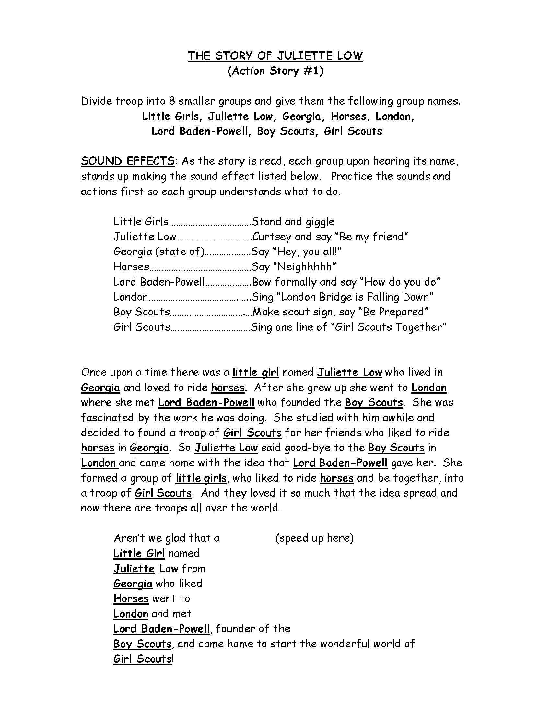

The Girl Scout law…

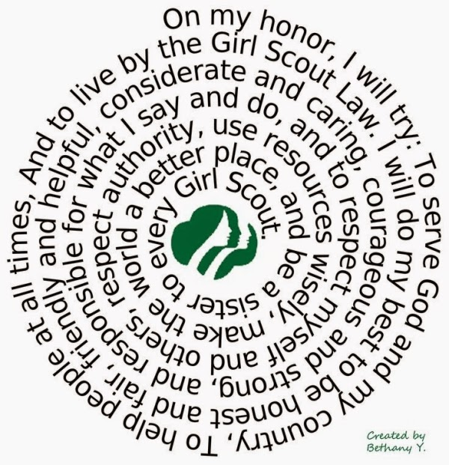

The Evolution of Girl Scout Pins…
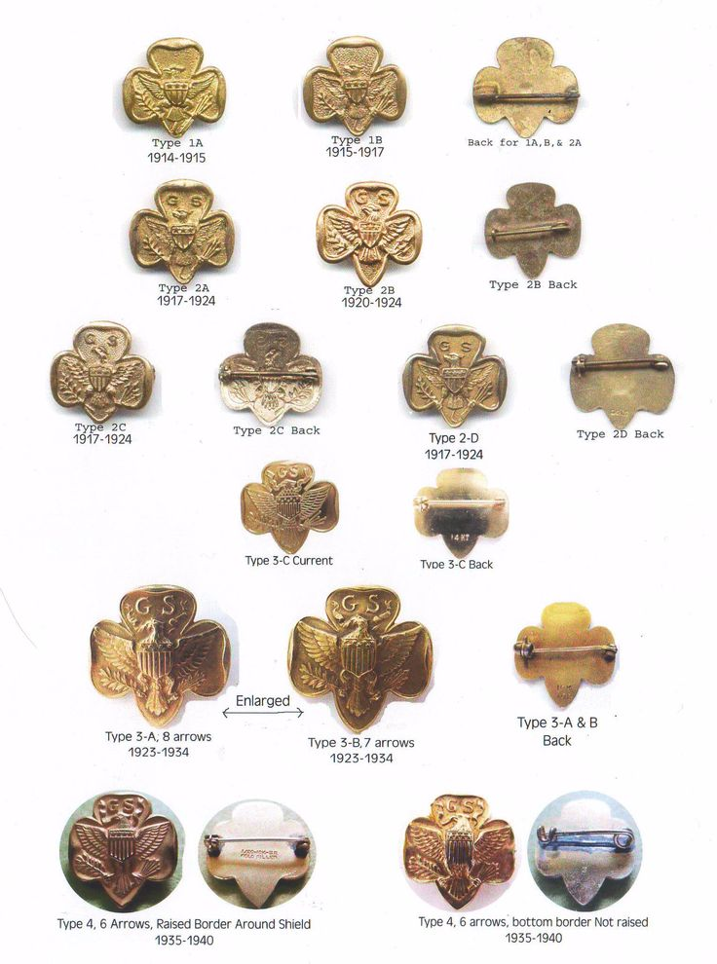

Friendship Bracelet pattern…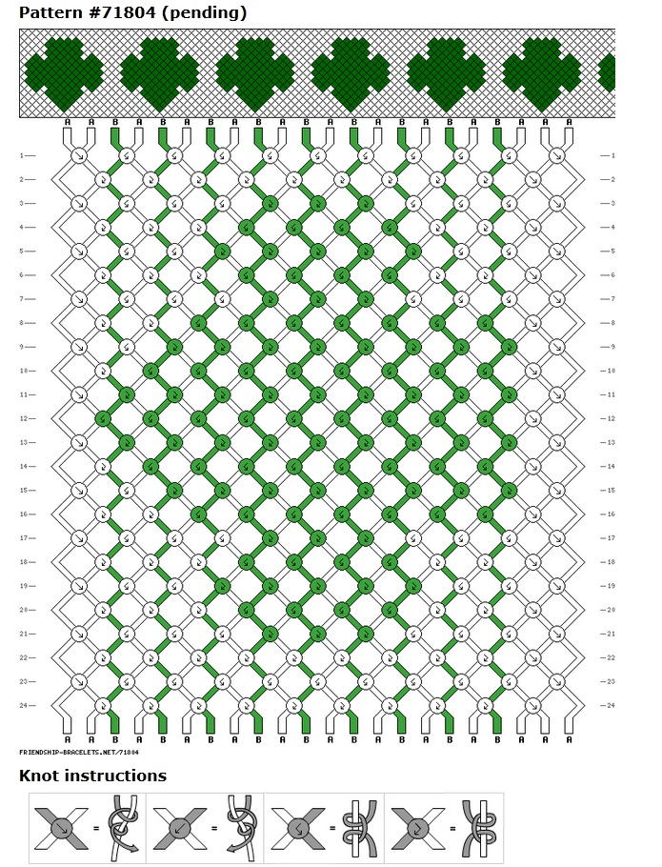
Girl Scout Beading or cross-stitch patterm…

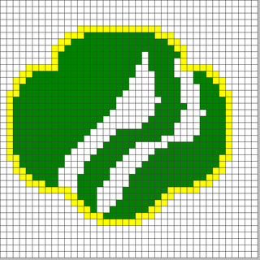

Girl Scout Promise Puzzle…

